Promotion Board Study Packet
(Can also be used for Cadet of the Month)

Created for use by CDT LT Traicoff

Enlisted Promotion board rubric:
(for officer promotion board, see Battalion commander for rubric)
Why should the board promote you? /5
(Tell the board why you should be promoted)
Current Events /5
(Describe a local, state, national and
world event down to the minute that it happens for most points)
Bearing /10
(This means your body and facial expression. Don’t fidget or move and don’t smile or look around. Keep your face neutral and look directly forward. Also, Do not move at all)
Uniform /10
(Keep your uniform in perfect condition with attachments in their place)
Stationary Movements /10
( Show how to do a correct left face, about face and right face)
Marching /15
(Know how to march correctly, ask your platoon sergeant/leader for more details)
23 Drill Commands /10
(Know all drill commands, listed below in the packet)
Command Voice /5
(speak in a loud, clear voice without stuttering)
Army/Cadet ranks 10 points each
(listed below in packet)
Army/Cadet chain of command
(Look at current chain of command on the battalion board and national chain of command board)

ALL OF BELOW LISTED IN PACKET
Cadet creed /10
20 Knowledge Questions /10
Phonetic Alphabet /10

20 Questions for yellow cord and cadet basic knowledge
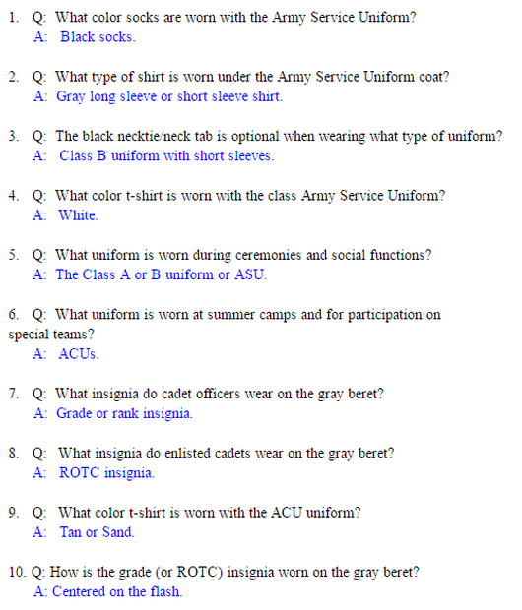
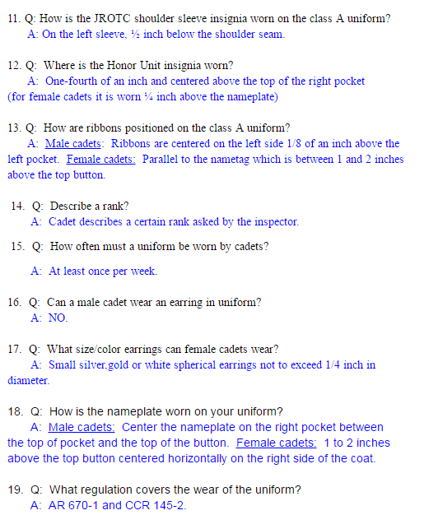
20. Q: Describe a rank.
THIS WILL BE SHOWN IN THE NEXT TOPIC

Ranks - Both Cadet and Army ranks

Cadet Ranks:
These are described as Chevrons and Bars for the enlisted and Spheres and Diamonds for the officers.
*For Cadet CSM, the middle is described as a wreath with a star in it.
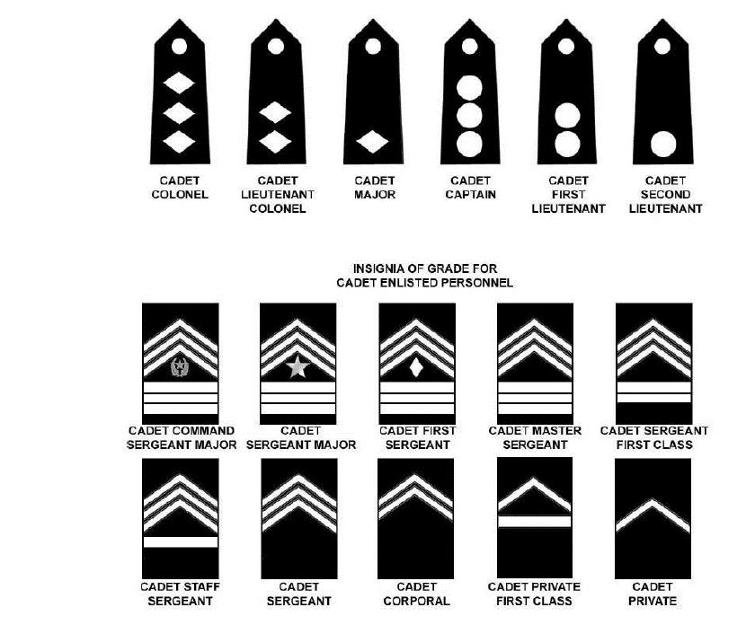
It is also useful to point out that the rank structure is a pattern, moving up chevrons and bars to finish at 3 each.
Army Ranks:
Army ranks are very similar to cadet ranks in the enlisted category. The only difference is bars are called rockers. The officer’s categories are different but still easy to describe.
*Specialist is described as a presidential seal in an inverted chevron and Sergeant Major of the Army has a presidential seal in the middle.
Warrant officers: are described as a black box inside a silver rectangle. The boxes then go up as W ranks go up. Master Warrant officer is described as 4 white boxes in 4 black boxes in a silver rectangle. In most promotion boards, you won’t need to know Warrant officers but it is always good to know them.

Commissioned Officers: They are described as gold/silver bars, gold/silver clovers and a silver eagle for colonel.
General Officers: The best way to describe them is by remembering this phrase. Be My Little General of the Army.
For each word, the generals go up a star. B is for Brigadier, M is for Major, L is for Lieutenant, G is for general, Of the army is for General of the army. They all are described as stars and go up by one each time.
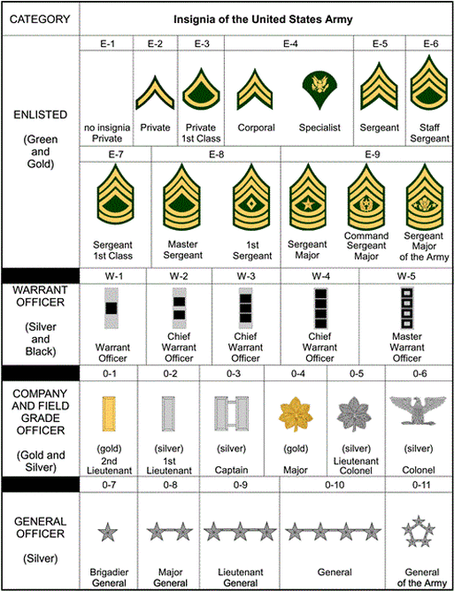
23 Drill commands
These are important for all promotion boards and are easy to memorise because they are so repetitive.

1. FALL IN
2. Dress Right, DRESS 3. Ready, FRONT
4. Present, ARMS
5. Order, ARMS
6. Left, FACE
7. About, FACE
8. Forward, MARCH
9. Column Left, MARCH
10. Left Flank, MARCH
11. Right Flank, MARCH
12. Column Right, MARCH
13. Right Flank, MARCH
14. Left Flank, MARCH
15. Column Right, MARCH
16. Rear, MARCH
17. Rear, MARCH
18. Column Right, MARCH
19. Column Left, MARCH
20. Column Left, MARCh
21. Squad/Platoon, HALT
22. (Leader faces unit, then commands) Left, FACE
23. FALL OUT
Cadet Creed and Phonetic Alphabet
The last things you need to know are your creed and phonetic alphabet.
